

*Presented by Care Groups*

**Welcome to the Care Hospital Website User Guide**

This guide will walk you through the features and functionalities of the Care hospital management website, designed to streamline and enhance interactions among administrators, doctors, and users (patients). The website offers three unique dashboards tailored to meet the needs of each user type.

The **Admin Module** is at the core of the hospital’s operations, giving administrators the tools to manage doctors, patients, and site content. Administrators can register new users, update existing records, and oversee the overall hospital data. This module ensures that all hospital activities are efficiently managed, creating a smooth experience for staff and patients alike.

The **Doctor Module** enables doctors to manage their profiles, view appointments, and access patient details as needed. Doctors can keep their schedules up-to-date, add qualifications, and update availability to better serve patients. This module helps doctors maintain organized records and communicate seamlessly with their patients.

The **User Module** is designed with patients in mind, allowing them to search for doctors, book appointments, and view medical information. This module provides patients with an intuitive experience to connect with healthcare providers, view their medical history, and keep track of upcoming appointments.

### **Admin Module**

Starting with the **Admin Dashboard**, let’s see that how it functions to support hospital management tasks.

### **Login Page**

To access the **Admin Dashboard**, users must first log in with their credentials. The login page requires an admin username and password to authenticate access. Upon successful login, the user is automatically directed to the admin dashboard, where they can manage doctor and patient information.

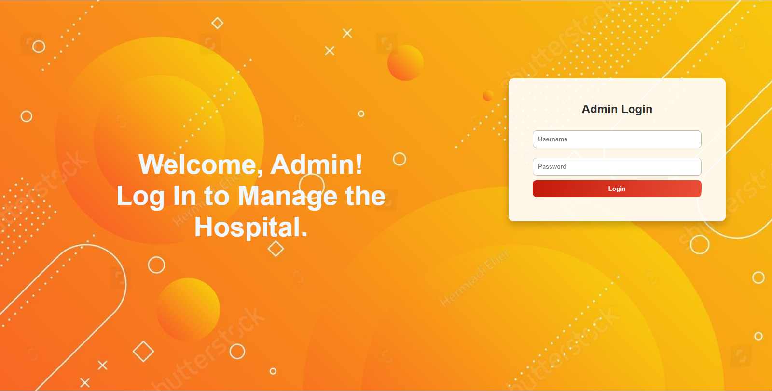 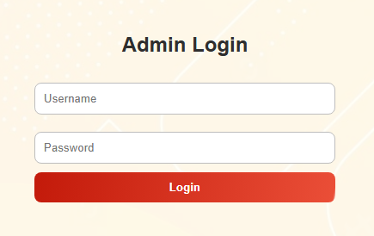

If the login attempt is unsuccessful—due to incorrect credentials or lack of an admin account—an error message will appear, guiding the user to re-enter the correct information or contact support if necessary.

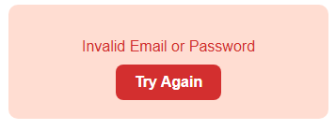

**Dashboard**

The **Dashboard** page provides a quick overview of the hospital’s activities, including recent registrations and updates on doctor and patient management. This section allows the admin to track ongoing tasks and identify any areas that need attention.

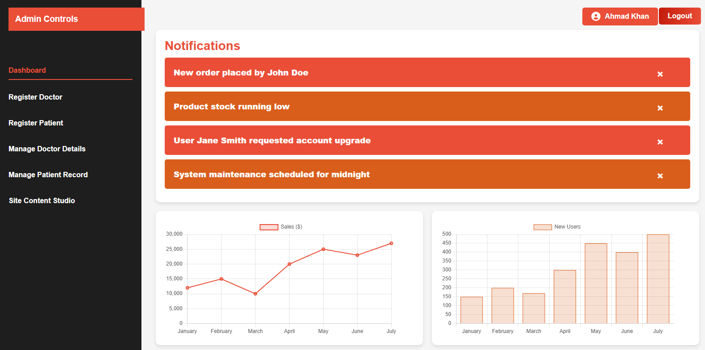

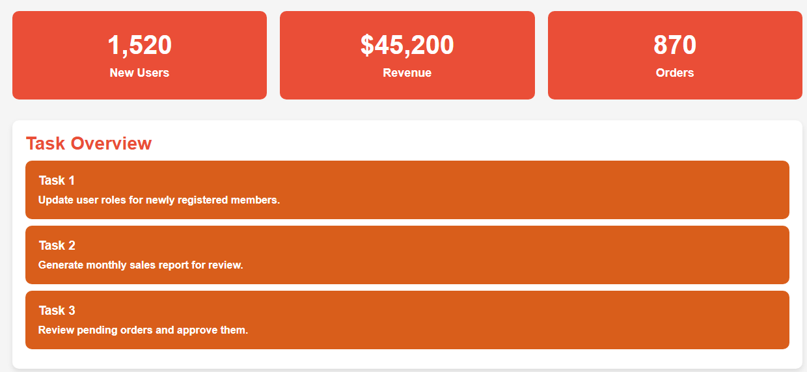

Upon accessing the **Admin Dashboard**, the admin will see a welcoming display featuring their name at the top of the page. This section provides easy access to their profile with a dedicated button showing their name. Alongside this, there is a **Logout** button, allowing the admin to securely log out from the dashboard if needed.

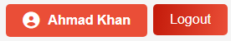

#### **Register Doctor**

In the **Register Doctor** section, administrators can add new doctors to the system by filling out their essential details, such as name, specialization, contact information, and any other necessary credentials. This page ensures that new doctors are entered accurately into the system.

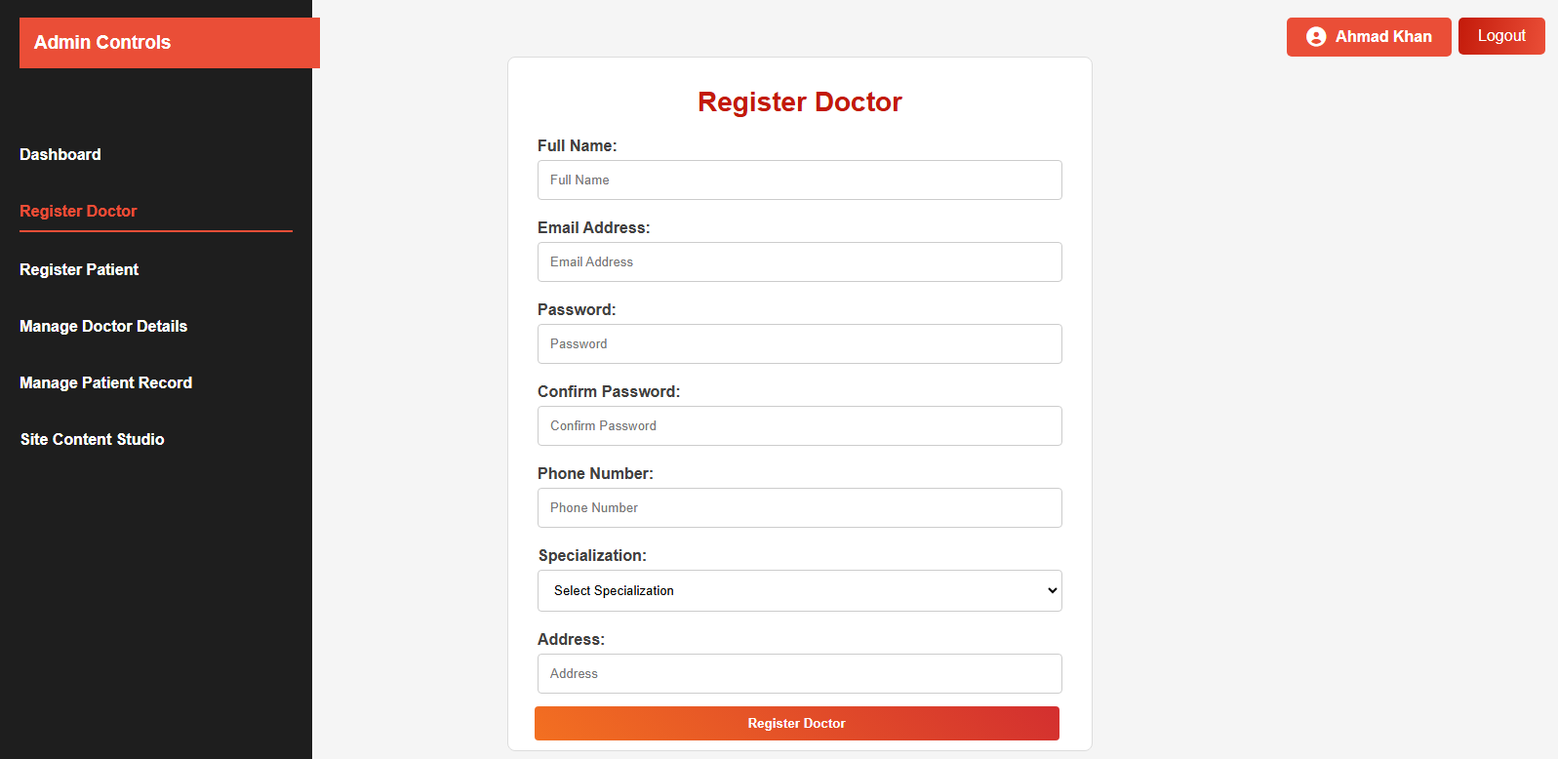

After successfully registering a new doctor, the admin will see a confirmation message displayed on the screen. This success message confirms that the registration was completed and the new doctor has been added to the system.

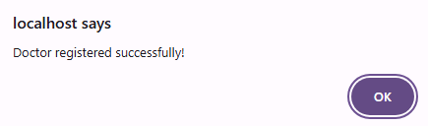

**Register Patient**

The **Register Patient** section allows administrators to register new patients into the hospital’s system. Similar to the doctor registration, this form requires details such as name, contact information, and medical history, helping keep patient records organized and accessible.

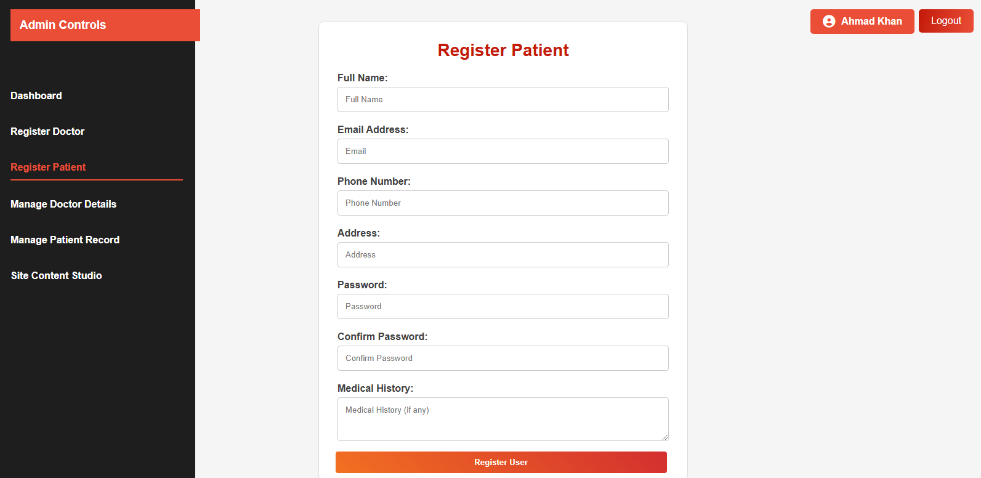

After successfully registering a new patient, the admin will see a confirmation message displayed on the screen. This success message confirms that the registration was completed and the patient has been added to the system.

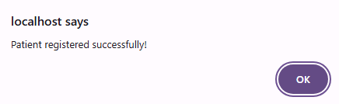

### **Manage Doctors**

In the **Manage Doctors** section, the admin can view a complete list of all registered doctors. Next to each doctor’s details, there are **Edit** and **Delete** buttons, enabling the admin to easily update or remove doctor records as needed.

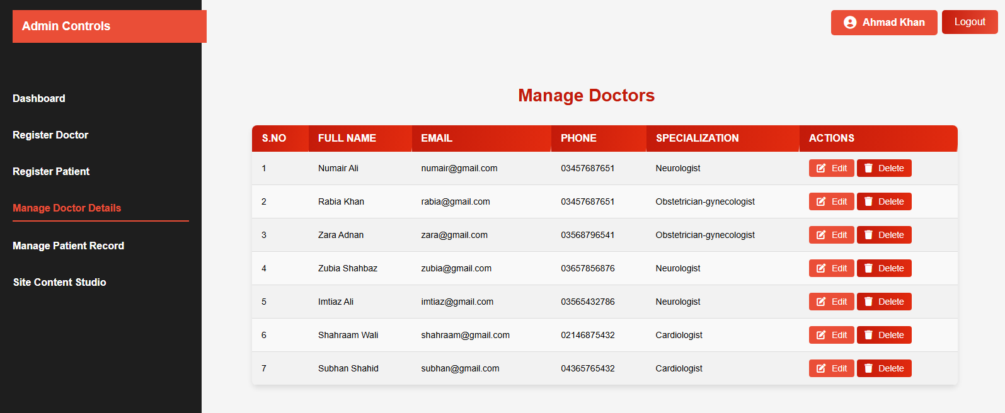



* **Edit**: Clicking the **Edit** button opens the doctor’s profile in an editable form. This form displays pre-filled information, allowing the admin to make updates to existing fields. Additional fields are also available to add new details, such as qualifications or availability. Once the updates are made, the admin can click **Update Profile** to save changes. A success message will confirm that the doctor’s profile has been updated.

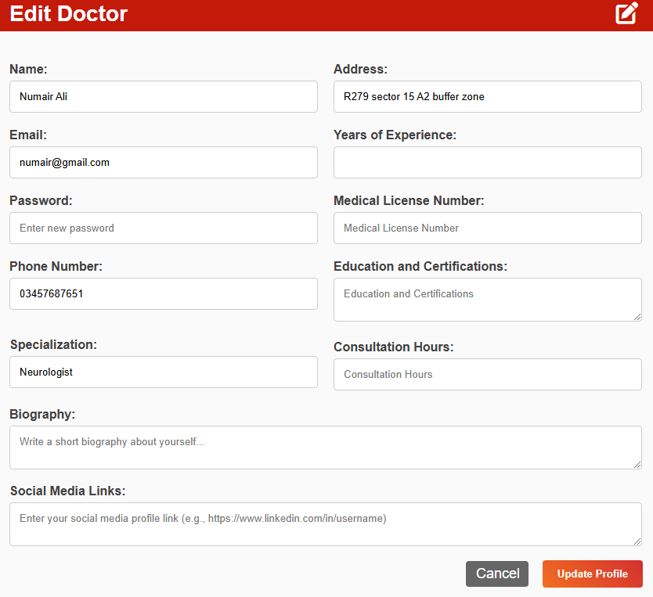

* **Delete**: Selecting the **Delete** button prompts a confirmation message, asking the admin to confirm or cancel the deletion. This ensures that doctor records are only removed with intent, adding an extra layer of security for data management. Doctor will be deleted when clicked OK.

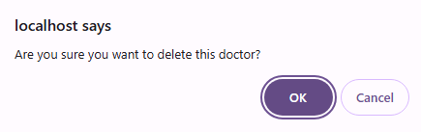

### **Manage Patients**

In the **Manage Patients** section, the admin can access a list of all registered patients. Similar to the doctor management page, each patient record displays **Edit** and **Delete** buttons beside their details, allowing the admin to efficiently manage patient information.

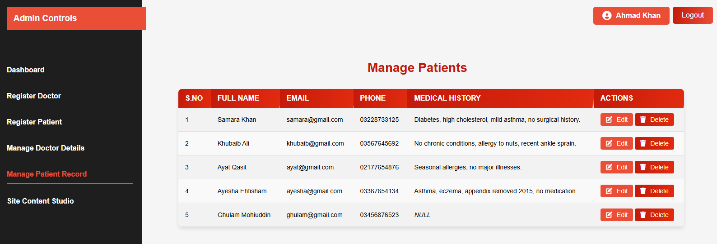



* **Edit**: By clicking the **Edit** button, the admin opens the patient’s profile in an editable form. This form includes pre-filled information, giving the admin the option to update existing details. Additional fields are also available to add any new information about the patient. After making the changes, the admin can select **Update Profile** to save the updates, with a success message confirming the profile has been updated.

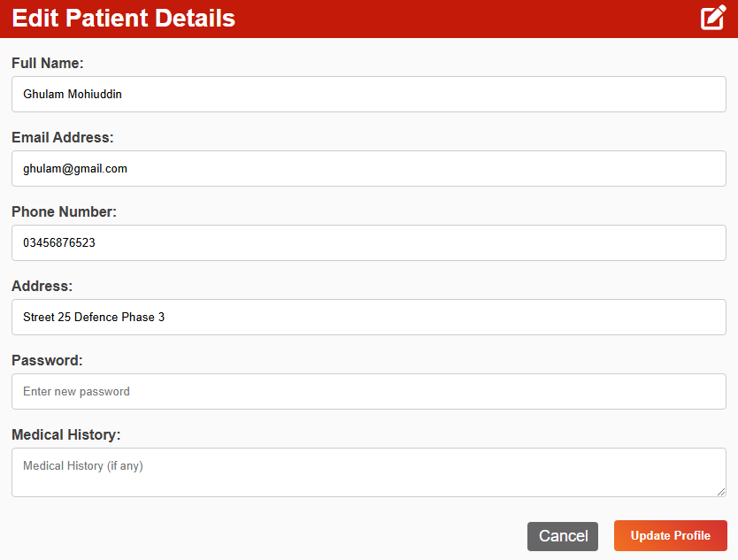

* **Delete**: When the **Delete** button is selected, a confirmation message appears, asking the admin to confirm or cancel the deletion. This precaution helps prevent accidental deletions and maintains patient data integrity. On clicking OK patient will be deleted from the record.

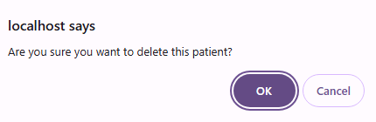

### **Site Content Studio**

The **Site Content Studio** allows the admin to manage content related to various diseases displayed on the website. Upon opening this page, the admin will see a list of all diseases currently featured on the site, each with **Edit** and **Delete** buttons next to it. In addition to editing and deleting existing entries, the admin has the option to add new diseases.

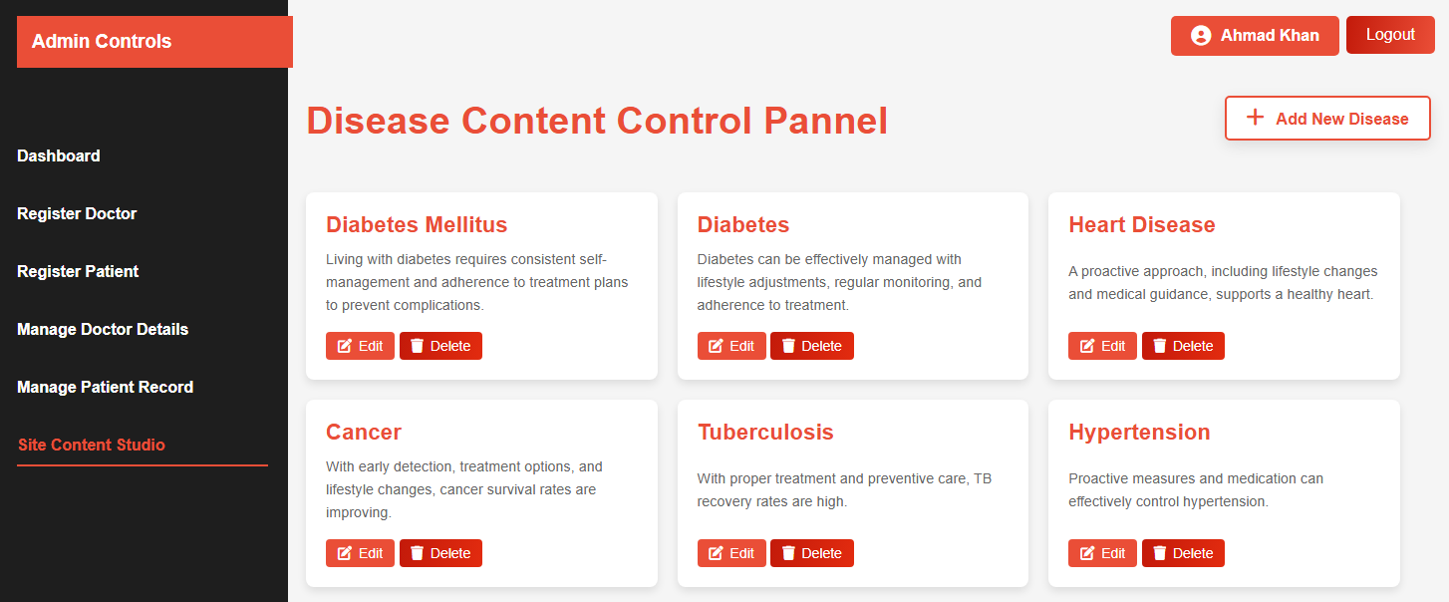

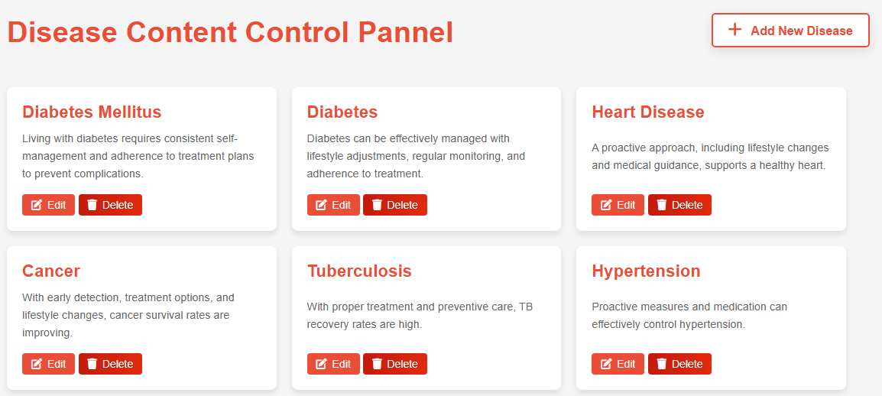

* **Add New Disease**: Clicking the **Add New Disease** button opens a form where the admin can enter details about a new disease, including sections like **Introduction**, **Symptoms**, **Preventions**, and **Conclusion**. This ensures that new entries are complete and informative. Once submitted, the new disease is added to the list, ready for users to view, and a success message confirms its addition.

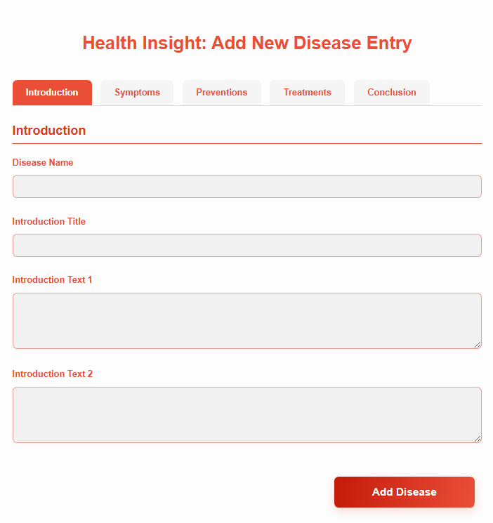

* **Edit**: When the **Edit** button is clicked, a dropdown menu appears for the selected disease, displaying editable sections such as **Introduction**, **Symptoms**, **Preventions**, and **Conclusion**.

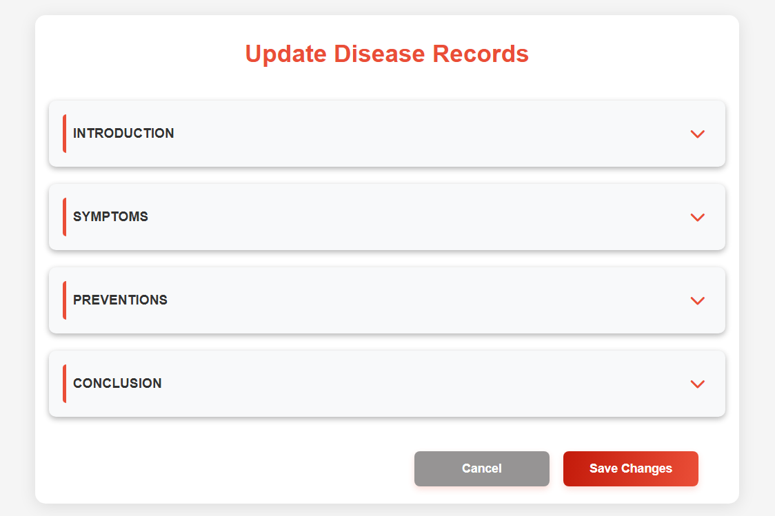

Selecting an option from the dropdown opens a form specific to that section, allowing the admin to update content accurately and in detail.

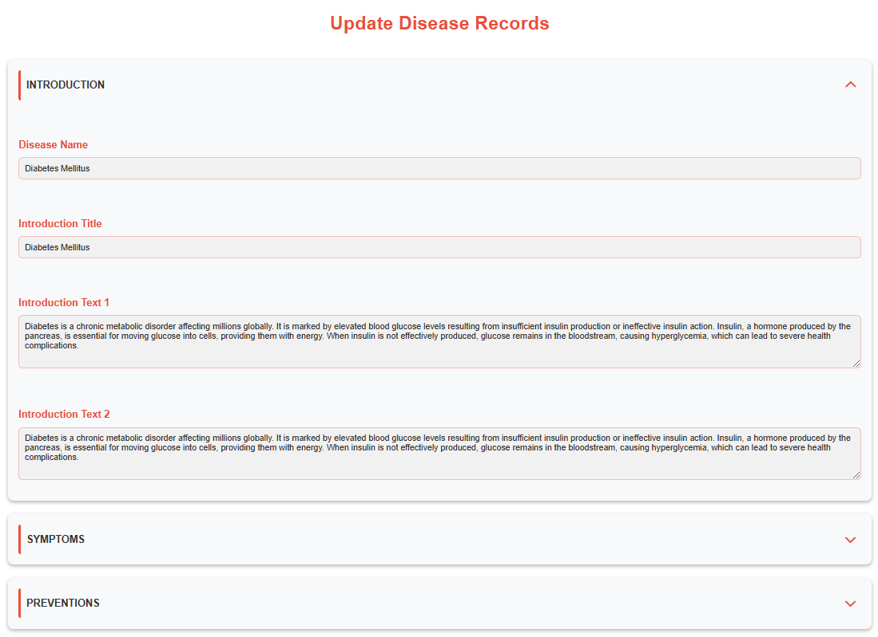

* **Delete**: Clicking the **Delete** button triggers a confirmation message, asking the admin to confirm or cancel the deletion of the disease content. This helps safeguard against accidental content removal.

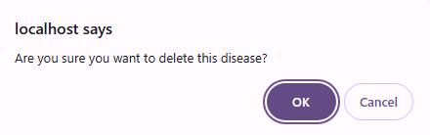

### **Conclusion of Admin Module**

The **Admin Module** empowers administrators to effectively manage the core elements of the hospital website, from registering doctors and patients to updating site content. With intuitive options for editing, adding, and securely deleting records, this module ensures that all essential information remains accurate and up-to-date, enhancing both hospital operations and user experience.

### **Doctor Module**

The **Doctor Module** is designed to help doctors efficiently manage their profiles, patient records, schedules, and appointments. This module provides doctors with the necessary tools to keep their information organized and to interact with patients directly, enhancing the overall quality of care provided.

### **Login Page**

To access the **Doctor Dashboard**, users must first log in with their credentials. The login page requires a doctor email and password to authenticate access. Upon successful login, the user is automatically directed to the doctor dashboard, where they can manage patient and their information.

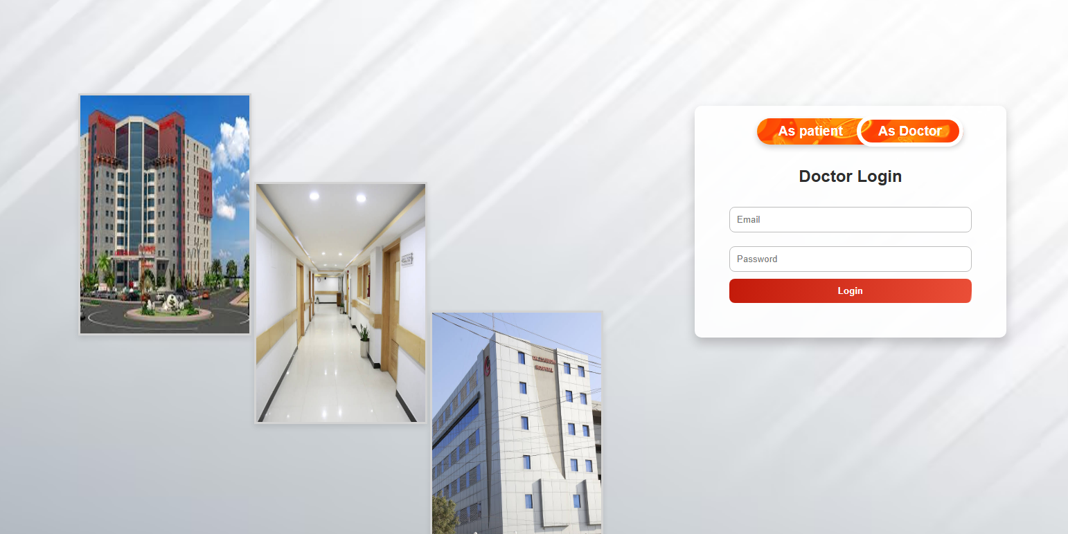

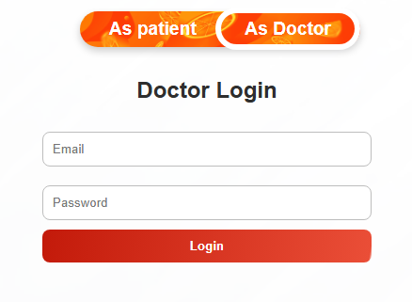

If the login attempt is unsuccessful—due to incorrect credentials or lack of an admin account—an error message will appear, guiding the user to re-enter the correct information or contact support if necessary.



#### **Dashboard**

Upon logging in, the doctor is taken to the **Dashboard**, where they can view an overview of the site content. This page displays essential information on the hospital’s services, general medical updates, and other resources available on the site, helping the doctor stay informed and connected with the site’s content.

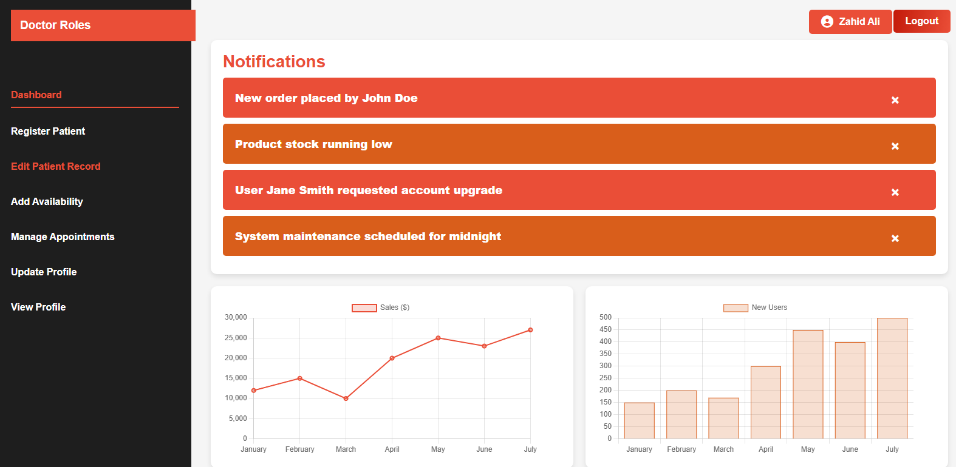

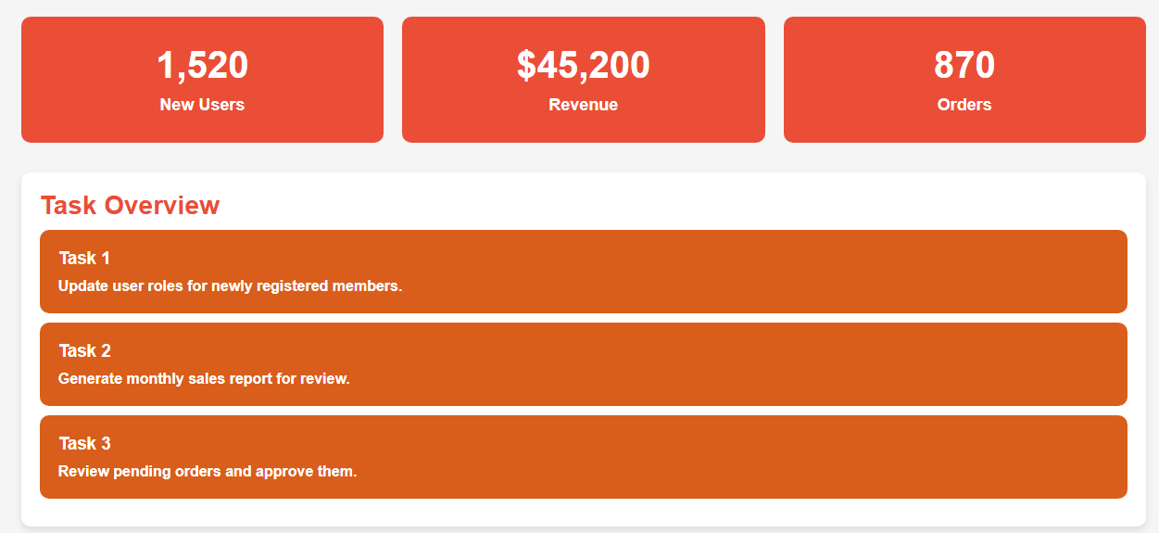

Upon accessing the **Doctor Dashboard**, the admin will see a welcoming display featuring their name at the top of the page. This section provides easy access to their profile with a dedicated button showing their name. Alongside this, there is a **Logout** button, allowing the admin to securely log out from the dashboard if needed.



### **Register Patient**

The **Register Patient** page allows doctors to register new patients and add them to the hospital’s system. This page includes a form that requires essential patient information, including:

* **Full Name**
* **Email Address**
* **Phone Number**
* **Address**
* **Medical History** (optional, to note relevant past medical conditions)

Once the form is filled out, the doctor clicks the **Register** button to complete the process. A confirmation message is displayed, indicating that the patient has been successfully added to the system. This ensures that all patient details are securely recorded and accessible for future appointments and medical records.

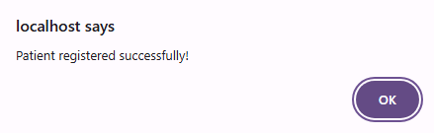

### **Edit Patient Record**

In the **Manage Patients** section, doctors can access a list of all registered patients under their care. Each patient record includes **Edit** and **Delete** buttons beside the details, enabling the doctor to efficiently manage and update patient information.

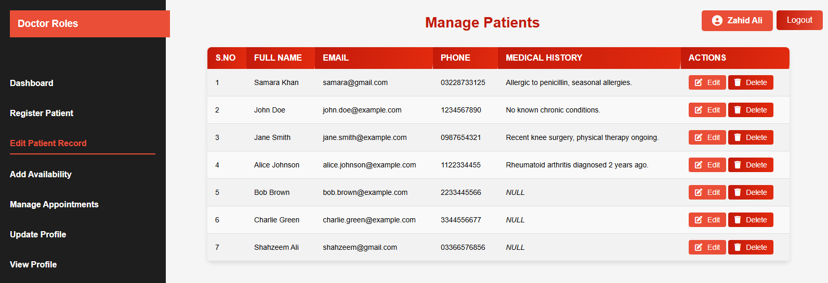



* **Edit**: By clicking the **Edit** button, the doctor opens the patient’s profile in an editable form. This form displays pre-filled information, allowing the doctor to update existing details, such as contact information, medical history, and other relevant notes. Additional fields are also provided to add any new information that may have been gathered during recent visits or consultations. After making the necessary updates, the doctor can click **Update Profile** to save changes. A confirmation message will verify that the patient’s profile has been successfully updated.

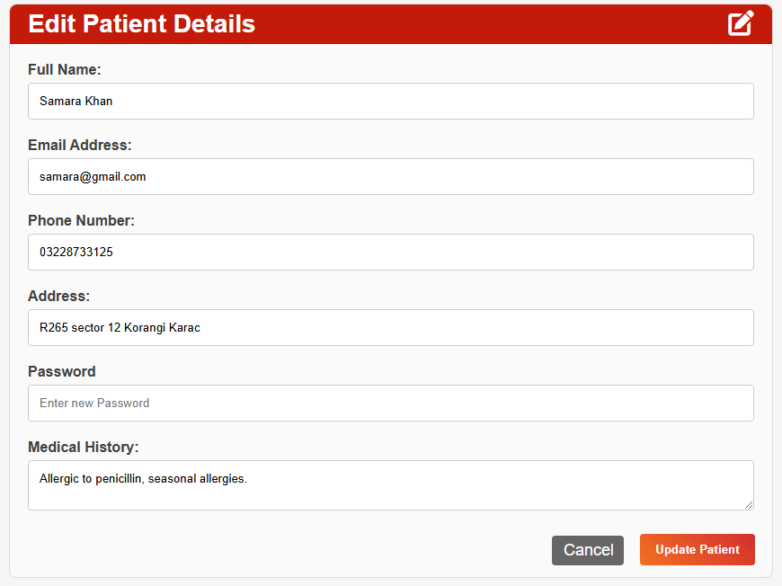

* **Delete**: Selecting the **Delete** button prompts a confirmation message, asking the doctor to confirm or cancel the deletion. This safeguard ensures that patient data is only removed with intent. Upon clicking **OK**, the patient record is permanently deleted from the doctor’s managed list.

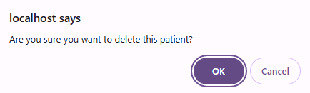

### **Add Availability**

This page allows doctors to set up their availability on a daily, weekly, or monthly basis to enable patients to book appointments within these times. The main features of the page include:

**Availability Modes**:

* + ***Daily****:* The doctor can specify available dates with start and end times for each day. These times are then divided into 30-minute slots to facilitate appointment bookings.
  + ***Weekly****:* The doctor can select specific days of the week (e.g., every Monday) and set start and end times for each day. This generates 30-minute slots only for the specified days of the week.
  + ***Monthly***: Doctors can choose a particular week and day in the month (e.g., the second Wednesday) to set available times, creating 30-minute slots for the selected day each month.

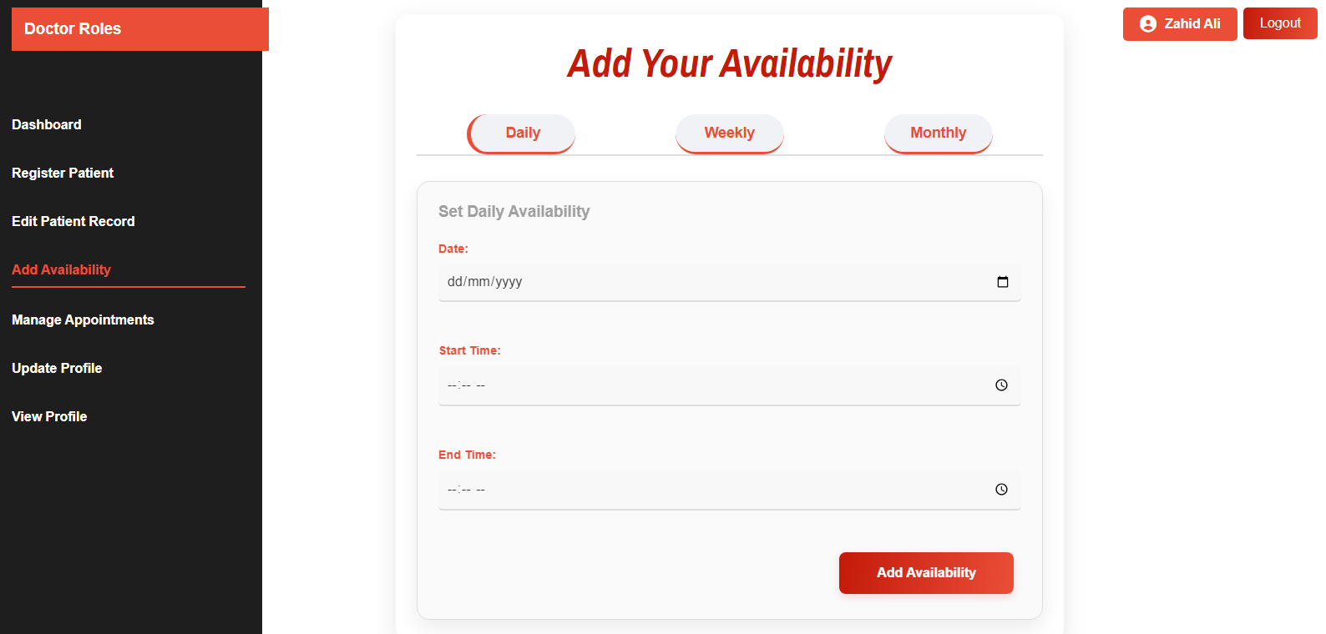

### **Manage Appointments**

The **Manage Appointments** page for doctors provides an organized view of all appointments booked by patients. Key features and functions of this page include:

1. ***Appointment Overview****:*
   * Doctors can see a list of all appointments, including patient details, date, time, and any notes provided at the time of booking.

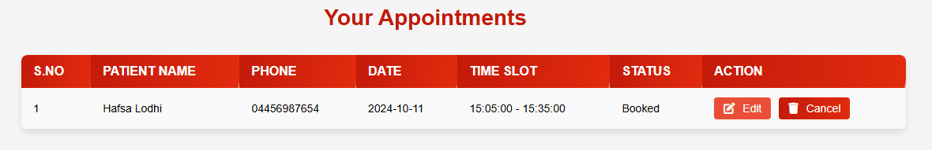

1. ***Edit and Cancel Options****:*
   * Each appointment entry includes two main actions: **Edit** and **Cancel**.
2. ***Edit Appointment****:*
   * Clicking the **Edit** button opens a dedicated **Edit Appointment** page, where doctors can make adjustment such as rescheduling the appointment time or updating any appointment notes.
   * This feature ensures flexibility in managing appointments if either the patient or doctor requires adjustments.

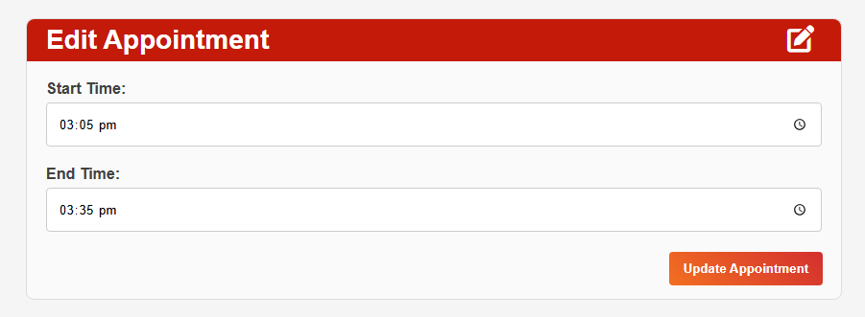

1. ***Cancel Appointment****:*
   * Clicking the **Cancel** button initiates a confirmation prompt to ensure that the doctor intends to cancel the appointment.

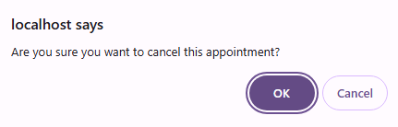

* + Once confirmed, the appointment is removed from the doctor’s schedule and may notify the patient about the cancellation.

This page streamlines appointment management for doctors, allowing them to keep track of patient visits and make adjustment as needed.

### **Update Profile**

The **Update Profile** page allows doctors to view and manage their personal and professional details, ensuring their profiles are comprehensive and current. Here’s how the page works:

Basic information fields, originally filled during registration (such as name, email, and phone), appear prefilled, allowing doctors to review and update any existing details if needed. Additional fields are included for doctors to add more information, such as years of experience, medical license number, certifications, education background, consultation hours, and a short bio. These details enhance their profiles, helping patients to better understand their qualifications. After making any desired changes, doctors can click the **Update Profile** button.

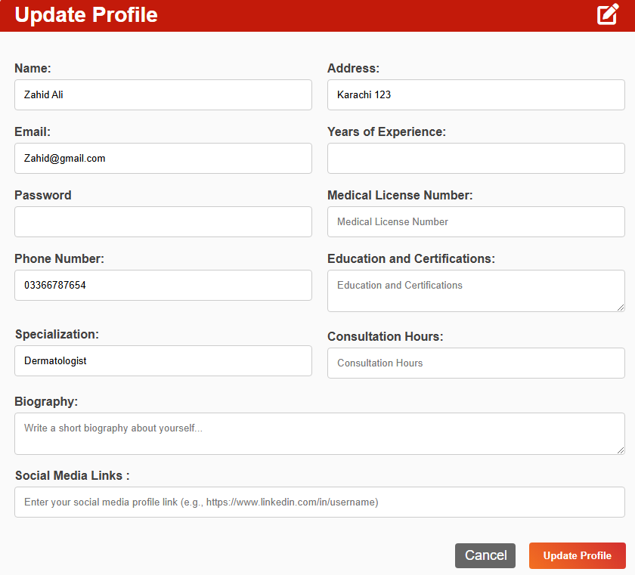

This action saves the updates and refreshes their profile with the latest information. Once updated a successful message is shown to users.

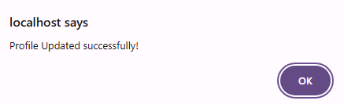

This page empowers doctors to maintain an up-to-date profile, ensuring their credentials and availability are accurate for patient viewing.

### **View Profile**

The **View Profile** page provides doctors with a complete overview of their current profile information in a read-only format. This page includes all key details, such as personal information, contact details, qualifications, and availability, as added in the **Update Profile** page.

* **Profile Overview**: Doctors can see all their profile information, including their name, specialization, experience, education, consultation hours, and other credentials, allowing them to verify how their profile appears to others.
* **Edit Profile Button**: This button is prominently displayed on the page. If the doctor needs to make any updates, they can click this button to be taken directly to the **Update Profile** page, where they can edit their information.

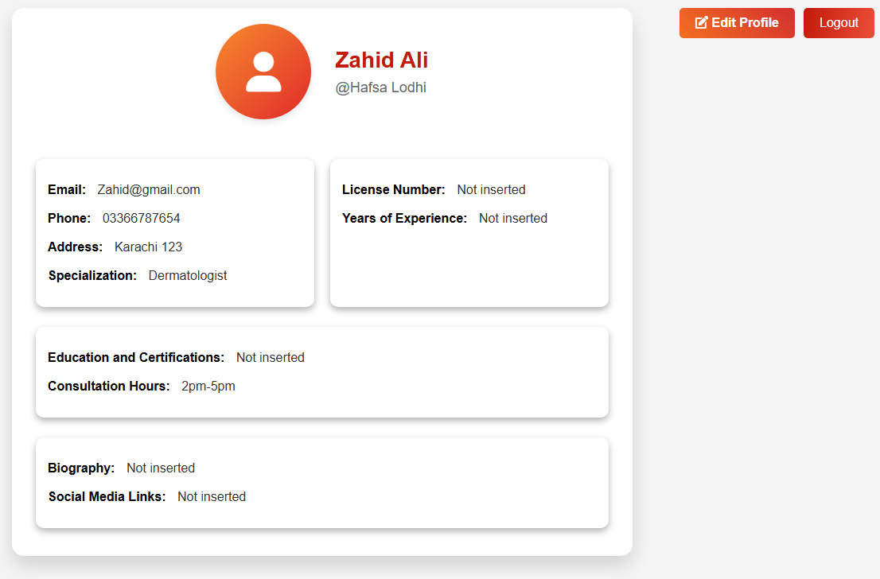

### **Conclusion of Doctor Module**

The **Doctor Module** in the hospital website provides a comprehensive, user-friendly interface that enables doctors to efficiently manage their profiles, appointments, and patient interactions. With features like appointment management, profile updates, and patient scheduling, this module supports doctors in streamlining their workflow and maintaining up-to-date information.

### **Patient Module**

The **patient** module is designed with a patient-first approach, ensuring easy access to essential healthcare features, intuitive navigation, and seamless interaction. Here, we’ll explore how users can effortlessly manage their appointments, search for doctors, and update their profile—all while maintaining a smooth and secure user experience.

The **Patient Module** provides a streamlined navigation and an intuitive interface for patients to access various features on the hospital website.

### **Navigation Bar**

The **navigation bar** includes the following menu options:

* **Home**
* **About Us**
* **Services**
* **FAQs**
* **Contact Us**
* **For Patients** (dropdown)



Under **for Patients**, patients can access:

1. **Search Doctor**
2. **Book Appointment**
3. **Manage Appointment**

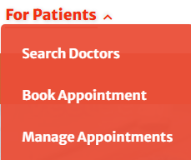

Alongside the menu, there is a **Login** button. Users can explore all pages without logging in, except the **For Patients** dropdown options. If a user attempts to access any page within this dropdown, they will be prompted to log in.



### **Login Functionality**

Once logged in:

* The **Login** button changes to display the user’s **profile name**.



* Clicking the profile name opens a dropdown box with:
  + A personalized greeting with the user’s name
  + **Logout**
  + **View Profile** button

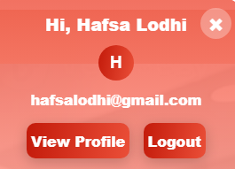

### **Profile Management**

In the **View Profile** page:

* Users can view their registration details.
* An **Edit Profile** button allows users to update information.

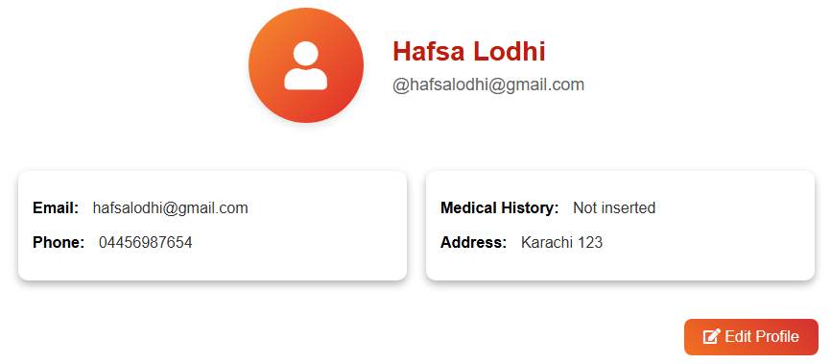

* After making edits, clicking **Update Profile** saves changes to the user’s records, keeping their information accurate and up-to-date.

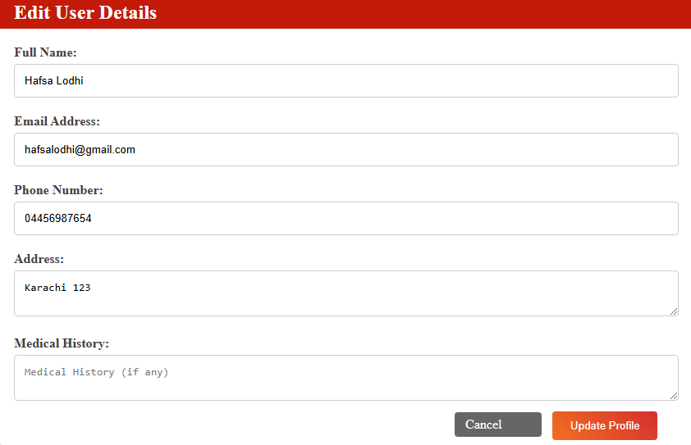

### **Home Page**

Now, let’s look at the **Home Page**, which serves as the central hub for users to access vital health information. A key highlight of this page is the **Diseases Section**, where users can learn about various medical conditions, including details on symptoms, prevention, and treatment options. For each disease listed, there's a **Read More** button that users can click to open a detailed blog post. This allows them to explore in-depth content on each condition, supporting informed health decisions and awareness.

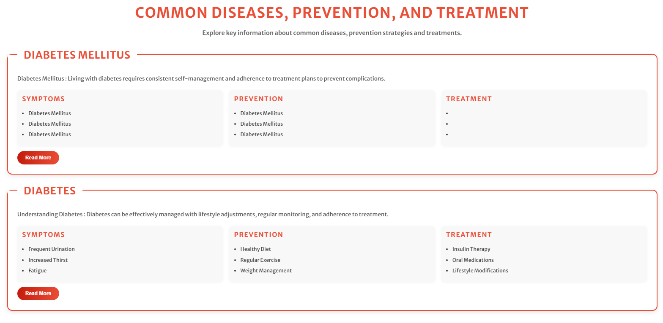

Rest of the home page looks like:



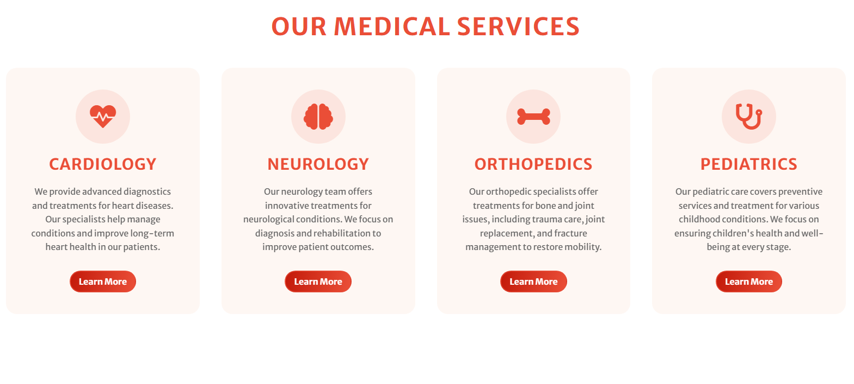



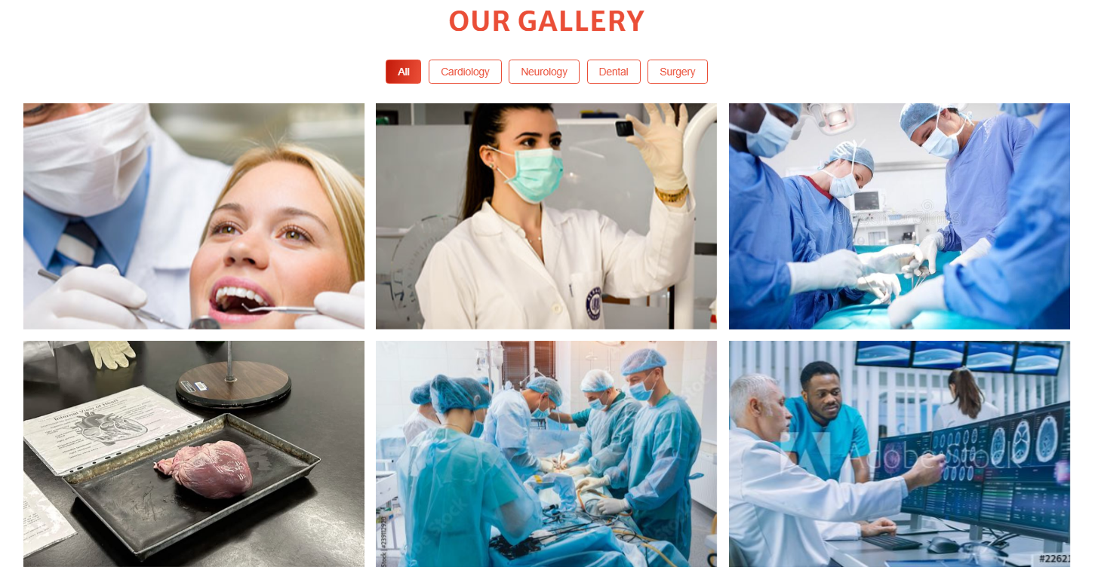

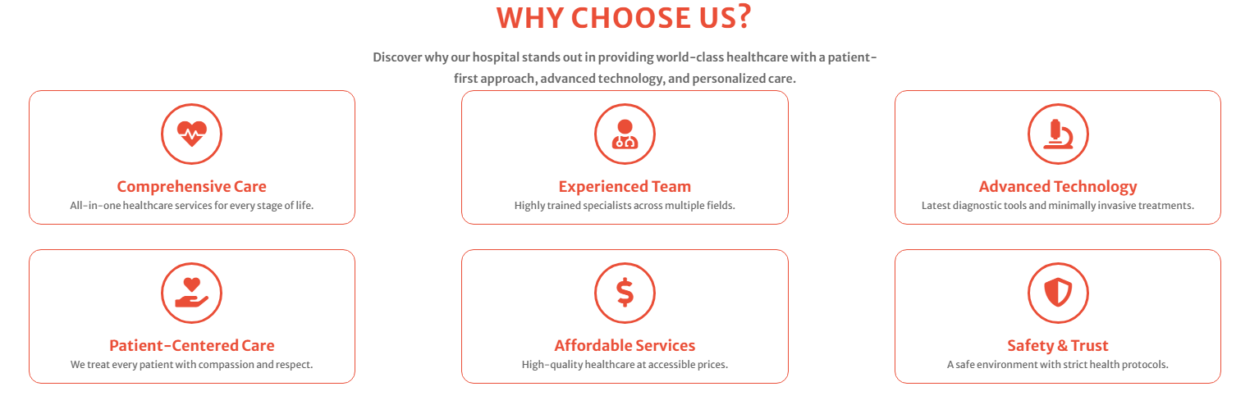









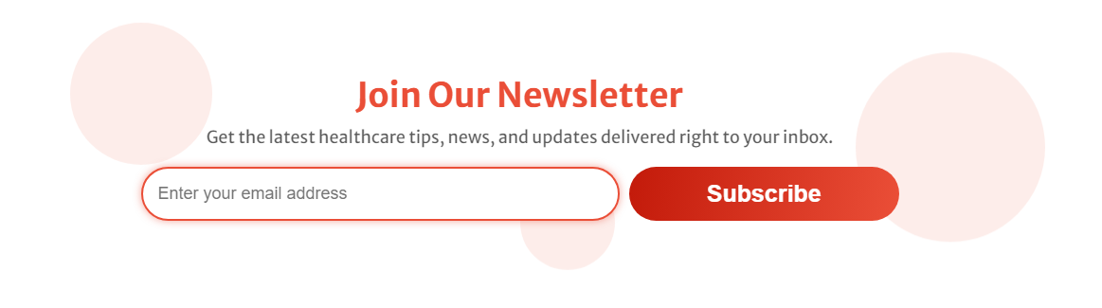

### **About Us**

The **About Us** page provides users with a comprehensive overview of the hospital's mission, values, and dedication to healthcare excellence. Here, visitors can learn about the hospital’s history, its commitment to patient care, and the guiding principles behind its services. This section also highlights the expertise and dedication of the medical staff, showcasing the hospital’s achievements, vision, and future goals. The **About Us** page aims to build trust by giving users a deeper understanding of the hospital's role in the community and its focus on delivering compassionate, high-quality care.

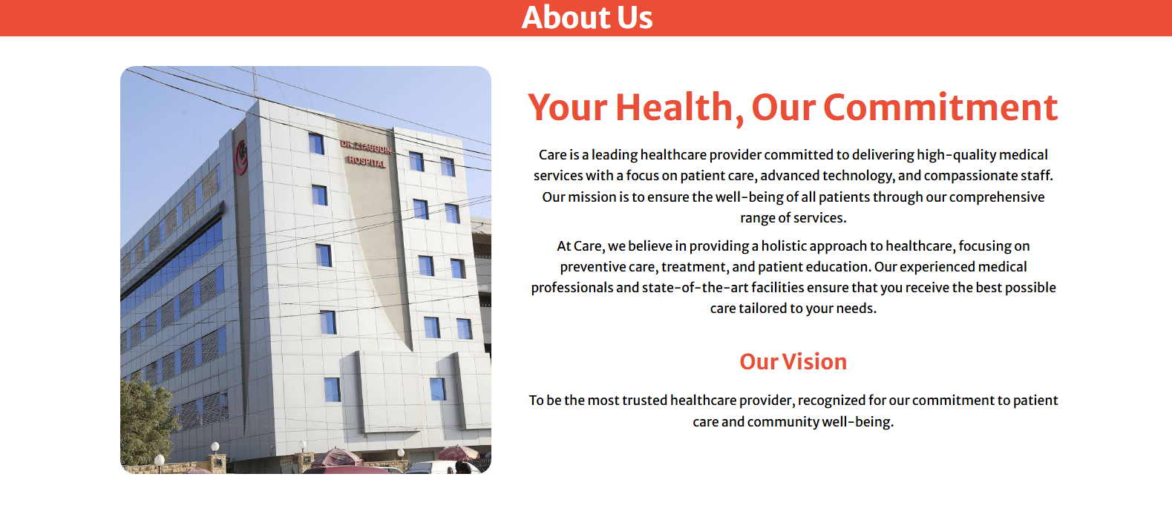



### **Services**

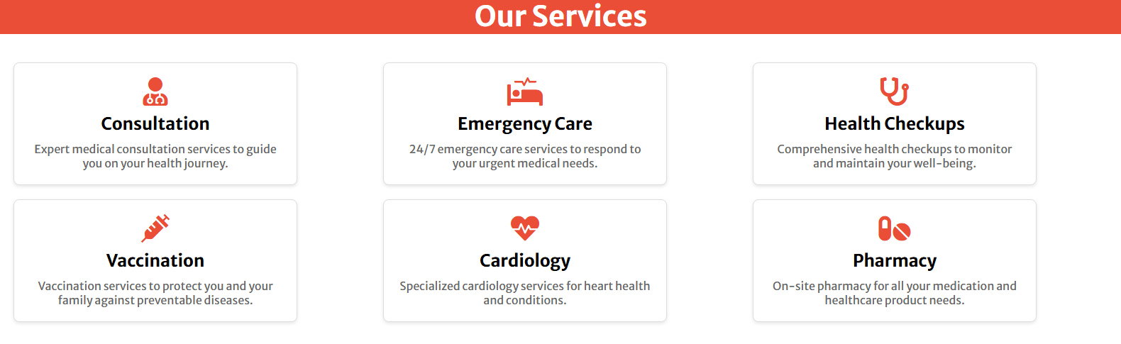

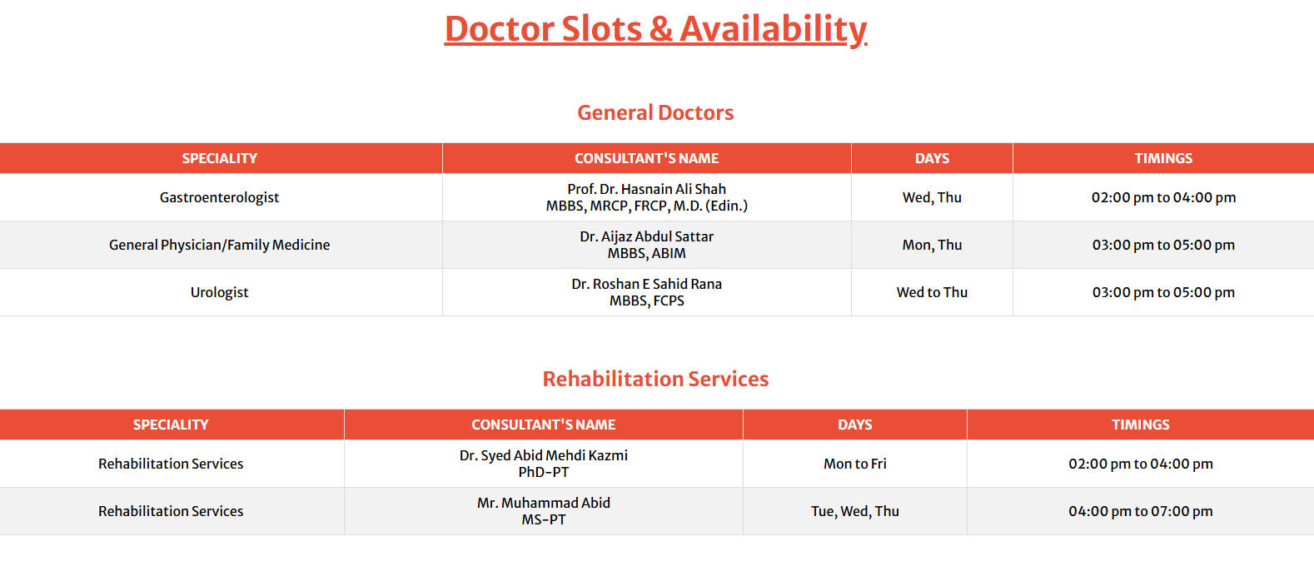

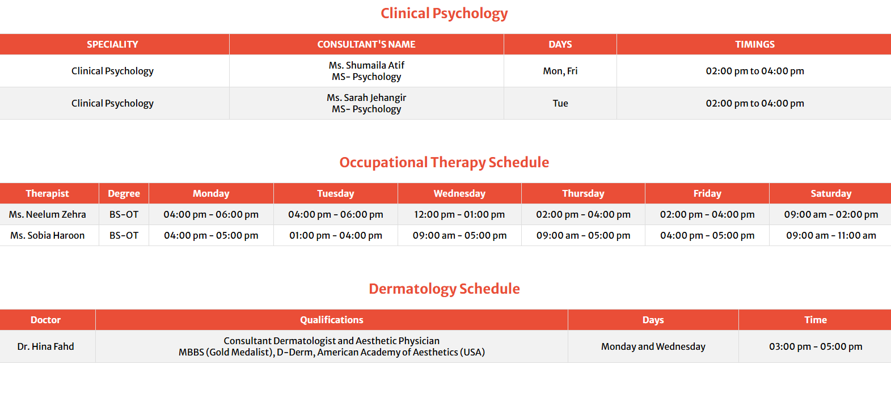

### **FAQs**

The **FAQs (Frequently Asked Questions)** page is designed to address common questions and concerns that users may have regarding the hospital’s services, procedures, and policies. This section covers topics such as appointment booking, consultation fees, insurance coverage, visiting hours, and guidelines for preparing for appointments. Each question is answered concisely to provide clarity and ensure patients can quickly find the information they need. This page is intended to enhance user experience by answering common queries, ultimately making navigation and use of the hospital’s services smoother for all patients.

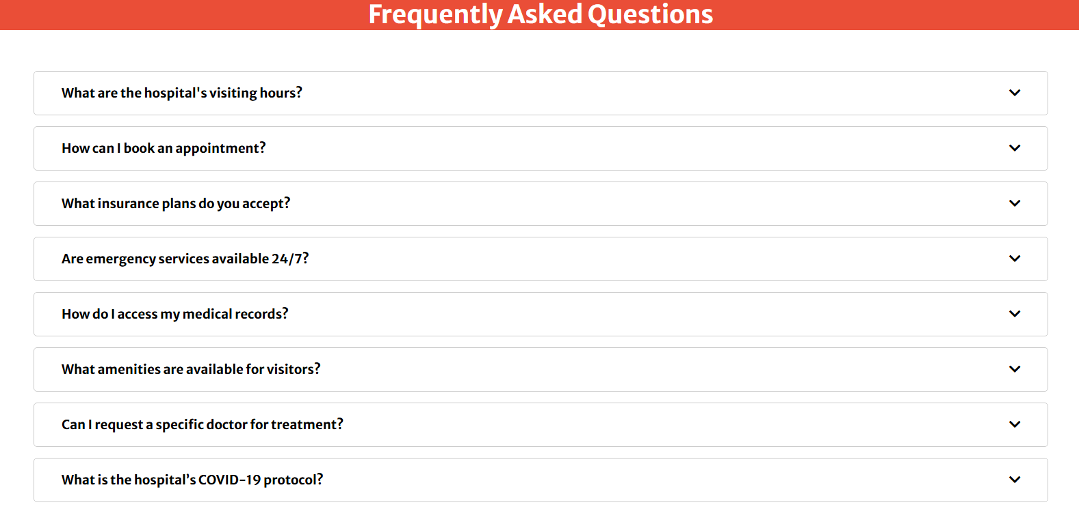

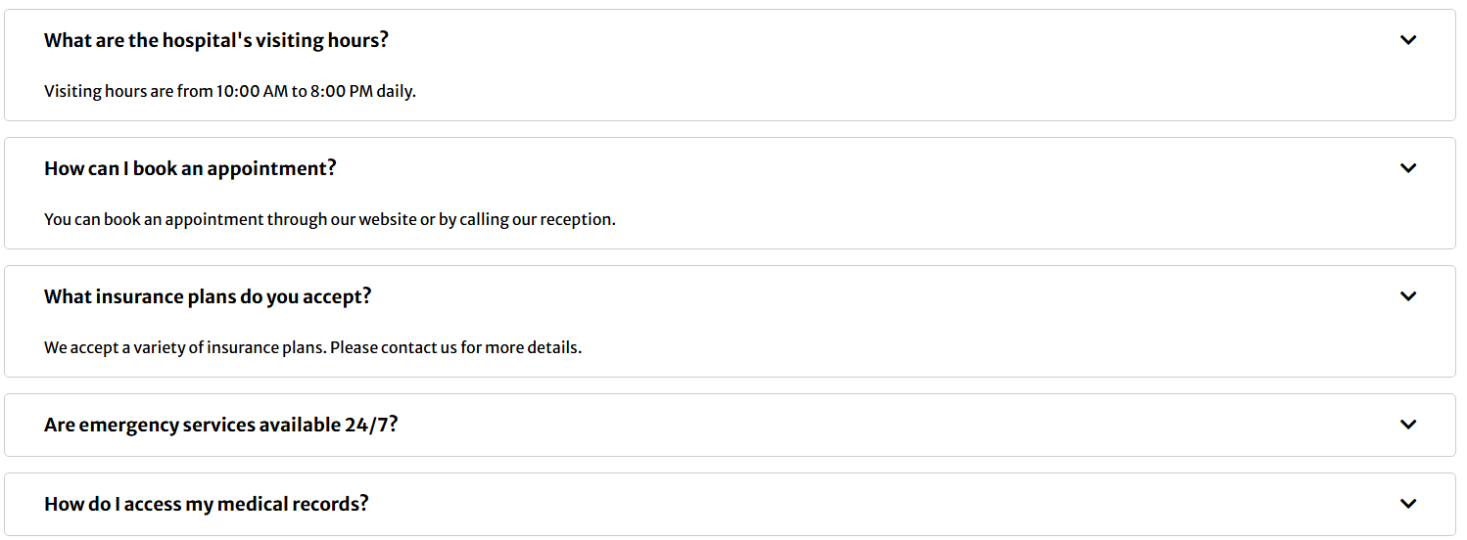

### **Contact Us**

The **Contact Us** page enables users to reach out to the hospital for inquiries, support, or feedback. Also this page allows users to fill out a contact form, entering details such as name, email, and message. When they submit the form, PHP Mailer handles sending the message directly to the hospital’s official email address, ensuring reliable email delivery and efficient communication. This setup is crucial for maintaining consistent and responsive communication between the hospital and patients, allowing the hospital to address patient inquiries promptly.



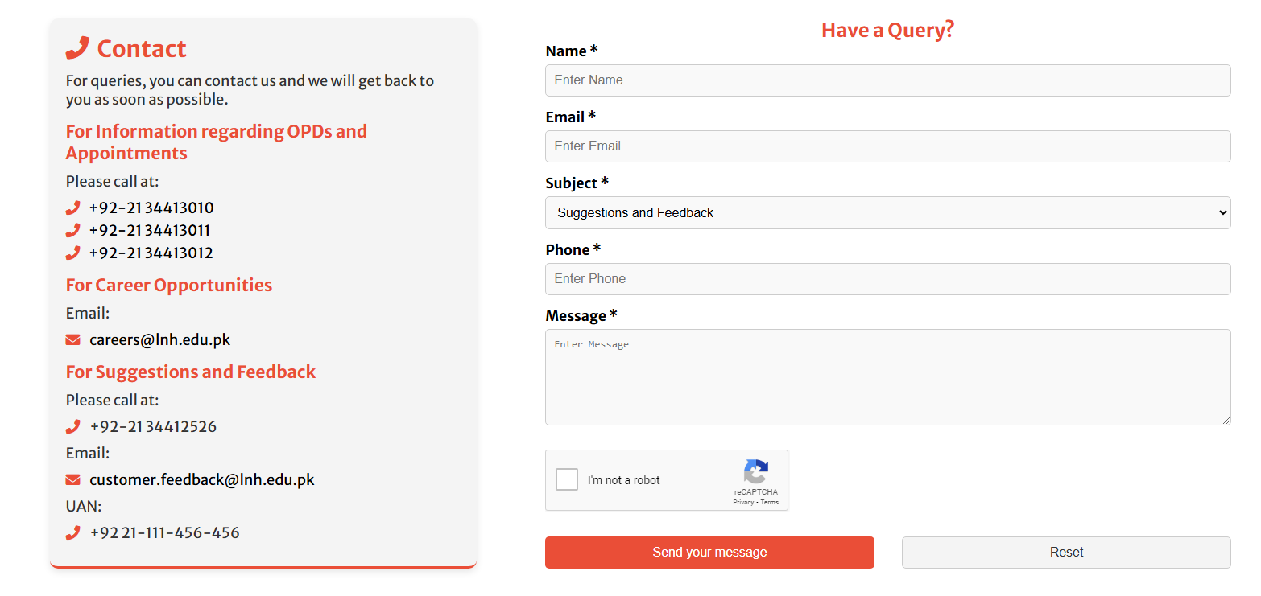

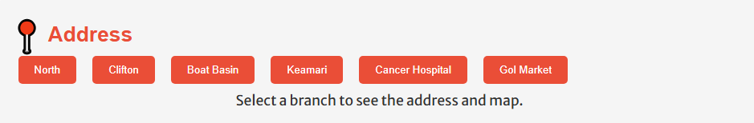

### **For Patients**

The **For Patients** section is a dedicated area designed to cater to the needs of registered patients, offering essential functions like searching for doctors, booking appointments, and managing existing appointments. This section is accessible via a dropdown menu labeled "For Patients" on the main navigation bar. Here’s a breakdown of its features:

1. **Search Doctor**: This page allows patients to search for doctors based on specialization, making it easy for them to find professionals tailored to their specific medical needs. Patients can filter the list of doctors to view relevant information such as each doctor’s qualifications, specialization, and consultation hours.

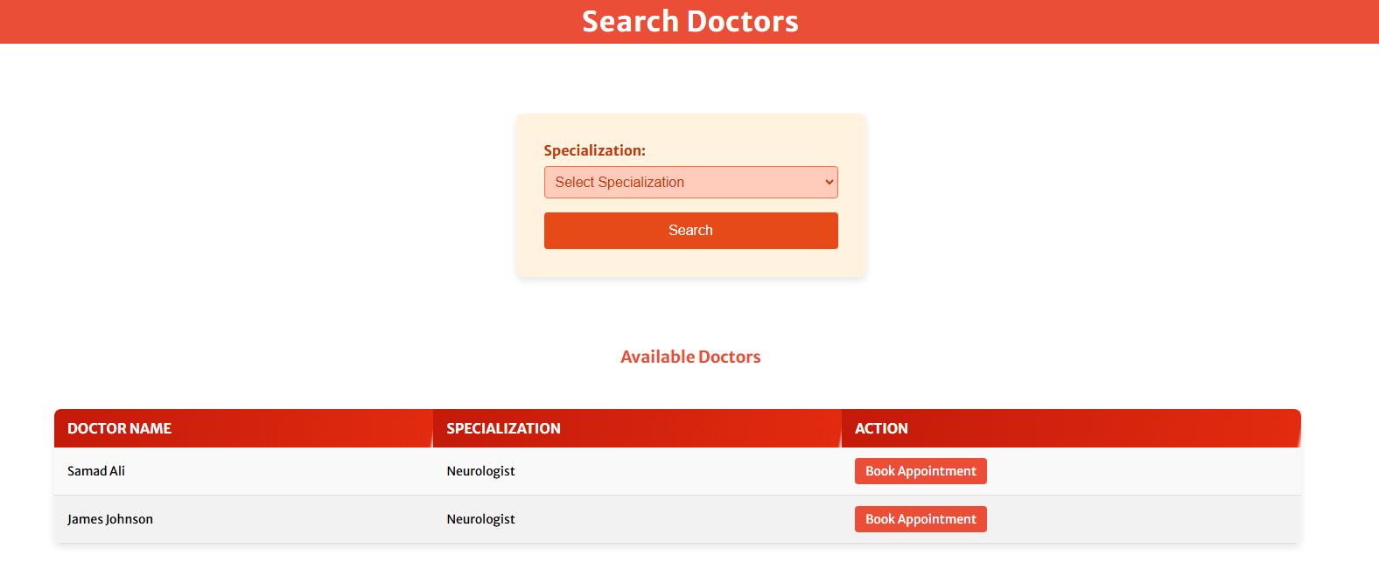

1. **Book Appointment**: Once a patient has identified a suitable doctor, they can proceed to the Book Appointment page. Here, the patient enters their details and selects a preferred appointment time to schedule a consultation. This streamlined process simplifies the appointment setup and ensures that necessary information is captured upfront, making the experience smooth and convenient.



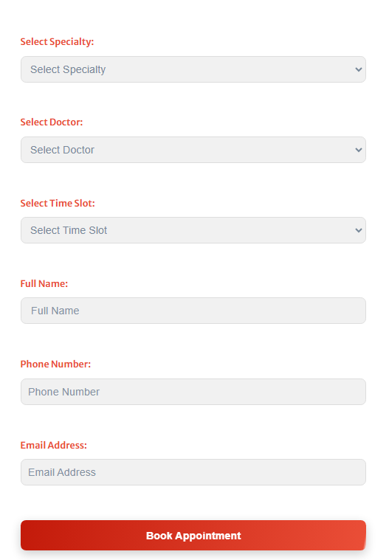

1. **Manage Appointment**: In this section, patients have the flexibility to review their upcoming appointments. They can also cancel appointments if needed, helping patients stay organized and make adjustments as required. For added confirmation, a prompt message is displayed before the cancellation is processed, allowing patients to confirm their choice and avoid accidental cancellations.

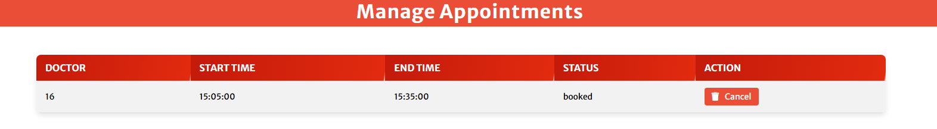

These pages together make the **For Patients** module a user-centered feature, providing patients with easy access to healthcare services and control over their interactions with the hospital.

### **Conclusion of Patient Module**

The **User (Patient) Module** is designed to provide a seamless and user-friendly experience for patients navigating through their healthcare needs. From the intuitive navigation bar to the well-structured pages for searching doctors, booking appointments, and managing existing appointments, each feature has been developed with the patient’s convenience in mind.

Patients can easily access essential information about diseases, explore available services, and reach out through the Contact Us page, all while being guided by a coherent interface. The profile management functionality ensures that patients can view and update their personal information, fostering a sense of ownership over their health records.

Overall, this module not only enhances patient engagement but also streamlines the process of accessing medical services, ultimately contributing to improved healthcare outcomes and satisfaction. By prioritizing user needs, this module exemplifies a commitment to delivering high-quality patient care and support.

**Thank you for reading our user guide. We hope this guide has provided you with a comprehensive understanding of our website’s features and functionalities. By utilizing the tools and resources outlined in this guide, you can enhance your experience and make the most out of your time on our platform.**

**If you have any questions or need further assistance, please don’t hesitate to reach out to our support team. We’re here to help you every step of the way.**

Happy Exploring!

Designed by: Hafsa Lodhi